**Iskala Raja Srinivas UID: 116190732**

**Nagireddi Jagadesh Nischal UID: 116190923**

**VEERESH AYYAGARI UID: 115602601**

**Report for Medical Robotics project**

2018

**Problem statement:**

Design and build a 3 Degree of Freedom Cartesian robot for Image Guided Brain Surgery.

**Introduction:**

A 3 Degree of Freedom Cartesian Robot which uses image guidance to detect Fiducial targets and moves the prismatic joints accordingly to hit Target points which are placed relative to the Fiducials. (Hidden from the robot camera). Target points are attained by processing MRI images through 3D Slicer. The software used for the robot control was MATLAB and Arduino IDE.

**Methodology:**

Step 1: Build and test a 1 DOF Linear stage robot.

In this step, we used Aluminum Extrusion bars and brackets were used to make the linear stage. L shaped brackets were machined using circular saw and vertical drilling machine. Each linear stage was one axis of the final robot. The motor was connected to the Arduino and the accuracy of the stage was checked. Repeatability check of the stage was also performed.

Step 2: Forward Kinematics simulation on MATLAB.

In this step, we modelled a 6 DOF Fanuc M-900 robot to compute the forward kinematics and plotted the robot. Similarly, these steps were repeated for a KUKA iiwa robot.

Step 3: Inverse Kinematics simulation on MATLAB.

Here, we build from the previous step adding inverse kinematics to our model of Fanuc M-900 and Kuka iiwa robot. Line and curve trajectories were used to test the algorithm.

Step 4: Medical Imaging.

In this step, we analyze 3D MRI scans consisting of three fiducial markers and targets. Slicer 3D software was used to get image dimensions and depth of the given markers and targets.

We calculated the centroids of the targets with respect to fiducial frame whose origin is taken as the second fiducial. Image segmentation was used to detect the centroids of the targets and fiducial markers.

Step 5: Combining 3 axes for the final robot.

For the final assembly, three group members combined our linear stages and used a rack and pinion with a needle as the z-axis. Re assembled the third linear stage and set up the camera and the fiducial holder.

**Homogeneous transformation from targets to needle frame:**

From pre-operative planning we found targets in fiducial frame and they are given as follows

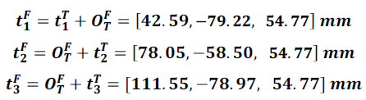

Camera calibration was done to find these fiducial markers in camera frame.

**Camera calibration:**

Calibration toolbox was used to compute intrinsic and extrinsic parameters of the camera,

This was done by taking multiple photos of checkerboard at different orientations, the toolbox returns the parameters.

After camera is calibrated centroids of the fiducials were obtained by performing HSV (Hue, Saturation, Lightness) for image segmentation, the fiducials found using this color space for segmentation were more accurate and consistent even with change in light conditions than RGB and lab color spaces in our case. For the next step these centroids were transformed from image frame to camera coordinate frame using the intrinsic parameters of the camera.

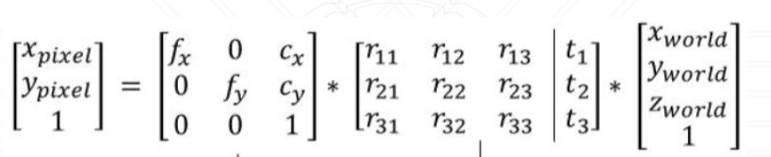

We used this transformation matrix to convert the pixel coordinates to the checkerboard coordinates and found the fiducial frame with respect to checkerboard frame.as the the matrix on right hand side has to be inverted to find the world coordinates (checkerboard coordinates), and the matrix is non-square pseudo inverse was used to invert this matrix. Later we used extrinsic to find the homogeneous transformation of fiducial frame with respect to camera frame.

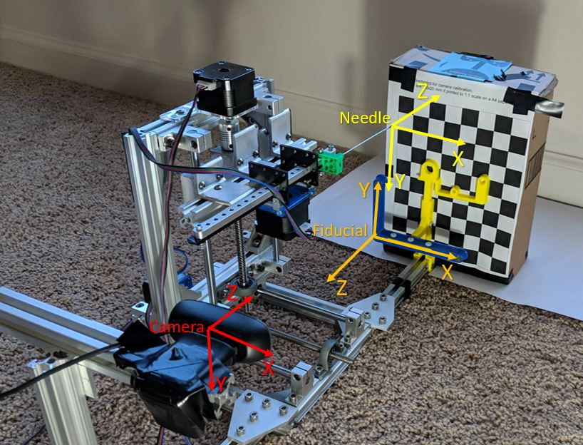

Figure Photograph of the robot with the frames

**Robot calibration:**

The main aim of this to find camera frame with respect to robot frame. For this the robot frame was chosen at tip of the needle which avoids calculating the various dimensions of the robot to find the needle in robot frame. For this a point on checkerboard is chosen which is taken as the home position of the robot. Now the robot is moved horizontally about two squares and the distance moved in three axes is calculated in terms of steps. Similarly, the robot was moved two squares vertically down from home position along the checkerboard. We got the x and y axis of the checkerboard frame; the cross product of x and y axes gave us z axis. So homogeneous transformation matrix was found that gave checkerboard in the needle (or robot frame). We know camera in checkerboard frame which is given by inverse of extrinsic parameters. So, multiplying these two matrices gave us matrix from camera in robot frame.

H0C = H0B*HBC

HoT= H0C *HCF*HFT

H0B is the Checkerboard frame in Robot frame

HBC is the Camera in Checkerboard frame

**Image Segmentation:**

We take a snapshot of the fiducial using the webcam and we converted the color space of the image from RGB to HSV. We then used ‘Imtool’ function on HSV image to find the threshold values that is best fit for segmenting fiducials. We then got a binary image and we removed blobs by thresholding on region properties values (such as area and eccentricity). Then, we perform dilation to smoothen the circles. We plotted contours and centroids for the fiducials.

**Image segmentation for different background conditions:**

As our team could not experiment with different backgrounds during the demo session, we have attached the fiducial marker identification using different backgrounds to check for the robustness of our image segmentation algorithm.

|  |  |
| --- | --- |
|  | White Background |
|  | Cardboard background |
|  | Checkerboard background |
|  | Cluttered background  (good lighting conditions) |
|  | Cluttered background  (poor lighting conditions) |

Our group tested the robot with changes in the fiducial markers in X, Y and Z directions and successfully implemented our project.

Here is a link to show the execution: [**https://www.youtube.com/watch?v=8lGLA1MarGY&t=32s**](https://www.youtube.com/watch?v=8lGLA1MarGY&t=32s)

**Recommendations and problems faced:**

A positional-feedback system for the robot would help a lot as we had a lot of difficulties during initial testing phase to understand if the robot is moving according to the given coordinates.

Firstly, one of the difficulties faced by us was that the needle tip given was bent from the start, we had to compensate for the error. The other problem we were facing was we could not input values to GUI from workspace in MATLAB which we later solved by using a function called ‘evalin’. Also, we had a lot of trouble with thresholding of the HSV values for segmenting the fiducials.

**Conclusion:**

We were successfully able to hit the target locations using our robot even when the fiducials were moved in X, Y and Z directions. This project gave us a practical exposure to concepts like forward and inverse kinematics, Image processing, Graphic User Interface and integration of Arduino with MATLAB program and a deeper intuition on how image guidance aided robotic surgery.